**1.**Python Program for Number of elements with odd factors in given range.****

def countOddSquares(n, m):

return int(m**0.5) - int((n-1)**0.5)

m = 100

print("Count is", countOddSquares(n, m))

**OUTPUT**

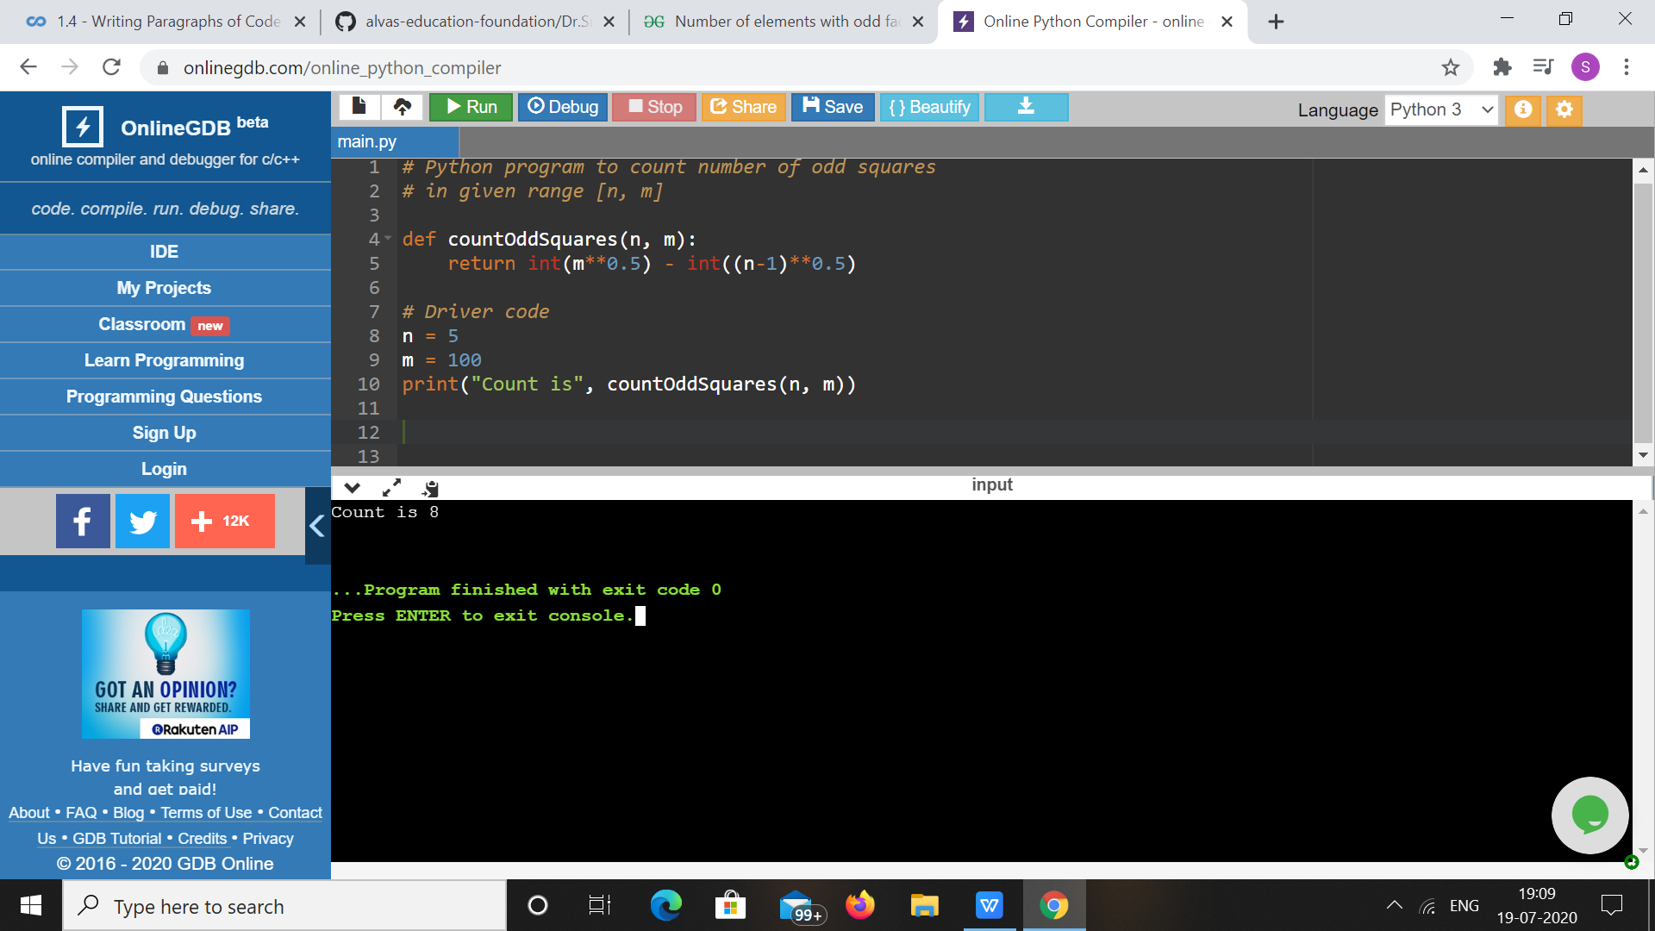

1. ****Python Program for Common Divisors of Two Numbers.****

**a = 12**

**b = 24**

**n = 0**

**for i in range(1, min(a, b)+1):**

**if a%i==b%i==0:**

**n+=1**

**print(n)**

**OUTPUT**

